dpic_lethal_election_2024_07_02
dpic
2024-06-21

Introduction

At A Glance
This is an R Markdown (R Version 2023.12.1+402) document describing the methods, data collection, and data analysis for the Death Penalty Information Center’s report, Lethal Election. We hope that those using this material will be able to reproduce our findings and/or contribute to further understanding of the impact of elections on the death penalty in the United States (US).

Suggested Citation
Lethal Election, Death Penalty Information Center, July 2, 2024.

Time Period
2013-2022

Spatial Domain
United States of America (USA); Georgia-US, Ohio-US, North Carolina-US; Harris County, Texas-US.

Study Purpose
The purpose of this research project is to understand the dynamics and impact of elections (judicial and within the executive branch) on capital punishment in the US.

What Was Done and Why?
For statistical analysis, data assessment, and visualization, we used R, Flourish, and Tableau Desktop (2024.1). We simultaneously collected data and ran analyses for two different scopes of the project: 1) Judicial and 2) Executive; searching for causal relationships between variables that could reject or support our hypotheses. Being aware of the multifaceted circumstances that death penalty decisions involve, we controlled for socioeconomic factors such as crime and murder rates, and gross domestic product per capita (for the respective state depending on the spatial domain of our assessment). Additionally, we accounted for instances where elections remained uncontested, and we explored the impact of the transitional period—also referred to as the lame-duck period; though, we also acknowledge that this term has recently been criticized for its ableist connotations (e.g., Stones, 2017).
Primary data collection involved the creation of a comprehensive dataset of death penalty cases reviewed between 2013 and 2022 by the state supreme courts of Georgia, Ohio, and North Carolina. We chose these states because they are similar in population size, they all have relatively large death row populations, and they are known as politically “purple” or “swing” states, which would (in theory) increase the likelihood of competitive elections and the political weight of judicial decision-making. While it is impossible to select an “average” death penalty state given the differences in use, procedures, and practices, these three states have sentenced to death and executed roughly similar numbers of people in the modern era (DPIC, n.d.). All three states of our focus elect Supreme Court justices, and at least one justice on each court is up for reelection every even-numbered year. In our review of the data, each case was coded for a variety of variables including outcome, each justice’s vote, legal claims presented, facts of the crime, and characteristics of the prisoner.
The total sample included every death penalty case decided by the state supreme courts between 2013 and 2022, totaling 110 cases. The sample comprised 73 observations from Ohio, 24 from Georgia, and 13 from North Carolina. Justices’ votes and case details were merged into one ‘master spreadsheet’ for further analysis. The master spreadsheet, which included DPIC original data cross-checked against the Westlaw database, was coded by two independent DPIC coders for justices’ authorship, votes, dissents; whether the justice was in an election year, and for the criminal case details, such as aggravating factors, number of victims, and claims, e.g., of prosecutorial misconduct. Each person’s data was then cross-examined by another team member. Additionally, various Microsoft Excel logical functions were performed to check for missing values and discrepancies to ensure data robustness.
Our socioeconomic information and criminal data came from the U.S. Census Bureau, Bureau of Economic Analysis, Bureau of Labor Statistics, Federal Reserve Bank of St. Louis, Federal Bureau of Investigation, and Centers for Disease Control and Prevention.
For the executive domain, we used existing DPIC data on clemencies, in addition to scholarly datasets compiled by Michael L. Radelet & Barbara A. Zsembik (1992) and Scott E. Sundby (2006). The dataset includes entries of executive clemencies (313 instances of clemencies for 146 observations—including instances of mass clemency in 2003 (167 cases) in Illinois and three federal/military clemencies).
This document contains the complete list of variables, datasets, and a detailed analysis description (with the respective R-script, as we hope to invite you to use our data and/or replicate our results). Among the methods used for inferential statistics, we utilized linear and logistic regressions to examine the relationships between predictor variables and both continuous and categorical outcome variables. We also assessed the nature, distribution, and potential multicollinearity of the variables, and performed robustness checks and model diagnostics. Nonetheless, as the death penalty has been a declining phenomenon in the criminal legal system, we faced small-scale datasets and sample sizes, which may affect the generalizability of our findings.

Research Questions:
Justices: How do outcomes for post-conviction capital cases decided by state supreme courts during election years compare to cases decided during non-election years?
Executives: Are executives more likely to grant clemency to death-sentenced prisoners when up for re-election or at the end of their tenure?

Hypotheses:
Hypothesis 1 (H1): State supreme courts are less likely to grant relief to death-sentenced prisoners when one or more justices are facing re-election. (null hypothesis: State supreme courts are equally likely to grant relief to death-sentenced prisoners in election years as in non-election years.)
Hypothesis 2 (H2): Elected executive officers (Governors and Presidents) exiting office are more likely to grant clemencies and mass clemencies compared to when they are up for re-election. (null hypothesis: Elected executive officers (Governors and Presidents) exiting the office are equally likely to grant clemencies and mass clemencies as when they are up for re-election)

Variables:

Dependent Variables
Variable Name | Coded as… | Description
Affirmed Sentences | affirm | indicating whether the appellate court affirmed (upheld) the death sentence issued by the lower court,coded as 0 for “no” (death sentence not affirmed) and 1 for “yes” (death sentence affirmed)
Number of Cases | case | a continuous variable indicating the number of capital cases
State Prevailed | state_prev_all | indicating whether a state prevailed in the case coded as 0 for “no” (state did not prevail) and 1 for “yes” (state prevailed)
Defendant Prevailed | defe_prev_all | indicating whether a defendant prevailed in the case coded as 0 for “no” (defendant did not prevail) and 1 for “yes” (defendant prevailed)
Reversed Death Sentence | rev_ds | a categorical binary variable indicating whether the appellate court reversed the death sentence without reversing the underlying conviction coded as 0 for “no” (death sentence not reversed) and 1 for “yes” (death sentence reversed)
Reversed Conviction | rev_con | a categorical binary variable indicating whether the appellate court reversed the defendant’s conviction, irrespective of the sentence—coded as 0 for “no” (conviction not reversed) and 1 for “yes” (conviction reversed)

Independent Variables
Variable Name | Coded as… | Description
Election Year | election | a categorical variable indicating election year or a non-election year; binary: 0 for non-election years, 1 for election years
Race | race_poc, race_l, race_b, race_w | a categorical (binary) variable indicating the race of the defendant or prisoner as per DPIC coding standard

Control Variables
Variable Name | Coded as… | Description
Contested Election | contested_bin | binary var: 0 for non-election contested years, 1 for contested election years
Population | pop | a continuous variable representing the total number of people living in a particular county/state
State/County Murder Rate per capita | smrpc, cmrpc | continuous variable indicating the number of murders relative to the population size in a state or county
GDP per capita | gdp | a continuous variable measuring the gross domestic product (GDP) of a county divided by its population
Unemployment | unemp | a continuous variable representing the percentage of the labor force that is jobless
Appellant | app_pri and app_stat | a binary categorical variable (0,1) whether the appellant was state or prisoner
Dissent | diss_bi | a categorical binary variable indicating the presence of a dissenting opinion filed in the appellate decisions related to the case
Substantive Ruling | subst_rul | a categorical binary variable indicating whether the appellate court’s decision in the case was based on substantive law—coded as 0 for “no” (decision not based on substantive law) and 1 for “yes” (decision based on substantive law)
Procedural Ruling | proc_rul | a categorical binary variable indicating whether the appellate court’s decision in the case was based on procedural law—coded as 0 for “no” (decision not based on procedural law) and 1 for “yes” (decision based on procedural law)
Reversed Non-Death Convictions | rev_other | a categorical binary variable indicating whether the appellate court reversed convictions that did not result in a death sentence, such as lesser felonies or misdemeanors associated with the case—coded as 0 for “no” (non-death convictions not reversed) and 1 for “yes” (non-death convictions reversed)
Multiple Offender | multiple_off | a categorical binary variable indicating whether the defendant/prisoner is considered as a multiple offender—coded as 0 for “no” (not a multiple offender) and 1 for “yes”
Number of Victim(s) | no_vict | number of victims in a capital murder case
Sexual Violence | sexual_violence | a categorical binary variable indicating the occurrence of sexual violence in a given incident or case. It is coded as 0 for “no” (no sexual violence occurred) and 1 for “yes” (sexual violence occurred)
Minor Victim | minor | a categorical binary variable indicating whether a victim was a minor (under the legal age of adulthood, which varies by jurisdiction), including the cases where sexual violence was perpetrated against minors. It is coded as 0 for “no” and 1 for “yes”
Partner | partner | a categorical binary variable indicating whether the victim was a romantic partner of the defendant. It is coded as 0 for “no” and 1 for “yes”
Peace Officer | peace_officer | a categorical binary variable identifies whether the victim was a member of law enforcement or representing a broader category of ‘peace officer’, coded as 0 for “no” and 1 for “yes”
Intellectual Disability Claim—Atkins | atkins | a categorical binary variable indicating whether the defendant has filed a claim of intellectual disability under Atkins v. Virginia—coded as 0 for “no” (no claim filed) and 1 for “yes” (claim filed)
Prosecutorial Misconduct Claim—Brady | brady | a categorical binary variable indicating whether the defendant has filed a claim of prosecutorial misconduct under Brady v. Maryland—coded as 0 for “no” (no claim filed) and 1 for “yes” (claim filed)
Prosecutorial Misconduct | pros_mis | a categorical binary variable indicating whether the defendant has filed a claim of other prosecutorial misconduct claim coded as 0 for “no” (no claim filed) and 1 for “yes” (claim filed)
Prosecutorial Misconduct Claim—Batson | batson | a categorical binary variable indicating whether the defendant has filed a claim of prosecutorial misconduct under Batson v. Kentucky—coded as 0 for “no” (no claim filed) and 1 for “yes” (claim filed)
Ineffective Assistance of Counsel Claim—Strickland | strickland | a categorical binary variable indicating whether the defendant has filed a claim of ineffective assistance under Strickland v. Washington—coded as 0 for “no” (no claim filed) and 1 for “yes” (claim filed)
Jury challenge—other | jury_ch_other | a categorical binary variable indicating whether the defendant has filed any other type of jury challenge not specifically covered by other categories (such as discrimination or misconduct claims) coded as 0 for “no” (no other jury challenge filed) and 1 for “yes” (other jury challenge filed)
Financial Gain Aggravator | fin_gain | a categorical binary variable indicating whether the crime for which the defendant is being tried included a financial gain aggravator—coded as 0 for “no” (no financial gain aggravator involved) and 1 for “yes” (financial gain aggravator involved)
Felony Murder | felony_m | a categorical binary variable indicating whether the defendant is charged with felony murder, which occurs when a death results from the commission of certain felonies, regardless of intent to kill—coded as 0 for “no” (not charged with felony murder) and 1 for “yes” (charged with felony murder)
Accomplices | accompl | a categorical binary variable indicating whether the defendant had accomplices involved in the commission of the crime—coded as 0 for “no” (no accomplices involved) and 1 for “yes” (accomplices involved)
Public Pursuit—manhunt | pursuit | a binary variable indicating whether the apprehension of the defendant involved a public pursuit or manhunt, signifying extensive law enforcement efforts to capture the defendant that engaged public attention—coded as 0 for “no” (no public pursuit or manhunt involved) and 1 for “yes” (public pursuit or manhunt involved)
Previous Capital Offender | prev_off | a categorical binary variable indicating whether the defendant has previously been convicted of a capital offense—coded as 0 for “no” (no previous capital offense conviction) and 1 for “yes” (has previous capital offense conviction)
Mental Disability | ment_diss | a binary variable indicating whether an individual has been diagnosed or identified as having a serious mental disability—coded as 0 for “no” and 1 for “yes”
History of Substance Abuse | substance | a binary variable indicating whether the defendant/prisoner has a history or current issue with substance abuse—coded as 0 for “no” (no history or current issue with substance abuse) and 1 for “yes”
Domestic Violence Survivor | dom_viol | a binary variable (0/1) indicating whether the individual is a survivor of domestic violence
Foster Care | foster | a binary variable (0/1) indicating whether the individual has been a client of the foster care system

Other Variables
Variable Name | Coded as… | Description
Prisoner/Defendant Name | name | last, first name
Current Case Status | stage | direct appeal, post-conviction, other
Year of Death Sentence | first, second, third | year of the first and consecutive (if any) death sentences
Case Filled Date | filled | a variable indicating the date on which a legal case was officially filed in the court
Case Citation | title | name of the capital case
Jurisdiction | state | state, federal, military, county (Harris, TX)
Appellant (nominal) | appell | case appellant: prisoner, state, other
Election Year (nominal) | yr_el | an indication whether case filed-date is in the election year
Author | author | last and first name of the supreme court justice identifying the author of a judicial opinion related to the case
Majority | majority | last names of justices, or ‘all’ for per curiam
Majority | maj_num | a continuous variable indicating the number of justices concurring
Dissenting Justices | dissent_jus | last and first name of dissenting justices identifying the author(s) of a judicial opinion related to the case
Dissent | diss_num | a continuous variable indicating the number of dissenting opinions filed in the appellate decisions related to the case

Important Findings

Justices
To better assess the election’s impact on the dependent variables, we compared the outcomes across different units of analysis: 1) defendant/case; 2) election year. For the latter, we created a new dataset that aggregated data based on the date when the case was filed. By ‘election year’, we understood a 12-month period before a general election date in a particular state of focus, e.g., for Ohio, the elections in 2018 took place on November 6th, and the election year, which also encompassed primaries, commenced on November 7th, 2017. Political scientists and economists have discussed the 12 months’ impact on a general election day. Especially considering primaries that may take place months prior to election day, the 12-month window is an adequate measure to indicate the potential effect of elections on judicial, prosecutorial, and executive decisions (Brookings, 1996; Gersen, 2011). In addition, we also controlled for the period where power is transitioned post-elections, a time that often allows for various—primarily unpopular or controversial—decisions to take place. This phenomenon has been widely discussed (e.g., Nagle, 2011), and in our research, it encompasses two months after the general election date.

Focus on an Election Year
We created new variables to indicate whether the case was filed during an election year. By ‘election year’, we understood a 12-month period before a general election date in a particular state of focus. For example, for Ohio, the elections in 2018 took place on November 6th, and the election year that also encompassed primaries commenced on November 7th, 2017. Please note that in Georgia, general elections for Supreme Court Justices take place in May (with an exception for 2020, when they happened in June).
Using R, we created a dataset that enabled us to compare the values across election and non-election years with the election year as a unit of analysis (in opposition to the case/defendant as a unit of analysis used for the Master Spreadsheet). Thanks to the function ‘mutate,’ we could:
Mutate and collapse/summarize the variables and data points for Georgia, Ohio, North Carolina, and their respective election years that were converted into the code. To select respective cases falling into the ambit of an election year or not, we referred to the date when the case was filed. We also collapsed other variables, such as whether elections were contested (contested_bin and contested score); whether the state or defendant prevailed (state_prev_all_bi / defe_prev_all_bi), number of victims, number of dissents, affirmed or reversed death sentences (along with the distinction between reversed convictions and reversed sentences), and others.
We created rows for the election year.
We created rows for the non-election year.
For the dataset where variables were analyzed through the unit of analysis, the election-year observed showed potential inflation of cases decided during election years (63 cases) compared to non-election years (37 cases). Only complete observations were used.
To analyze the impact of election years on the number of affirmed death penalty cases, a Wilcoxon rank-sum test (Mann-Whitney U Test) was performed for a variable indicating the number of affirmed cases (‘affirm’) and a categorical binary variable election (‘election’). We chose this non-parametric test due to its robustness in handling non-normally distributed data and its ability to compare the central tendencies. It compared the distribution of affirmed cases between two groups: years with an election (‘election’=1) and years without an election (‘election’=0). The median of affirmed death penalty cases was higher in election years compared to non-election years. The findings were significant at a p-value of 0.036 (for an alpha of 0.05). The median value for the non-election year is about 3, while for an election year, it is 6. Using the measure of median values with the Wilcoxon test helped to control for outlier cases and their distribution. The significant difference in median values suggests that the central tendency ‘shifts’ depending on whether there is an election year or not.This shift may indicate that electoral cycles influence judicial behavior.
Figure 1. The Wilcoxon Test for Affirmed Death Penalty in State Supreme Courts (2013-2022)
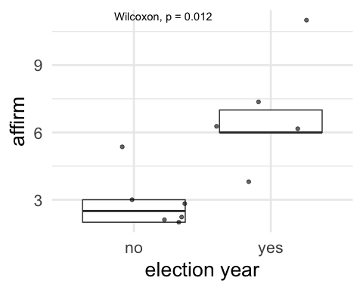
It is also worth mentioning that the means and medians for the following variables were higher in election years but not statistically significant: the number of justices joining the majority in deciding the case (maj_num), the number of dissenting justices (diss_num), and the number of substantive rulings given in election years.
We also corroborated these outcomes by performing both linear and logistic regressions on categorical outcome variables across different units of analysis and controlling for the number of cases as well as socioeconomic factors.
Figure 2. Logistic regression output for a categorical outcome variable ‘affirm’ (the number of affirmed death penalty sentences)
## Term Estimate Std.Error Odds.Ratio Conf.Low Conf.High P.Value
## 1 (Intercept) -2.1222796 0.5658138 0.1197583 0.03950711 0.3630246 0.0001762399
## 2 election 0.9723829 0.4362917 2.6442380 1.12440191 6.2184123 0.0258308676
## 3 no_vict 0.8639054 0.2650085 2.3724079 1.41126829 3.9881286 0.0011144520
Figure 3. Coefficients Chart with Margins of Error for a categorical outcome variable ‘affirm’ (the number of affirmed death penalty sentences)
## Loading required namespace: broom.mixed
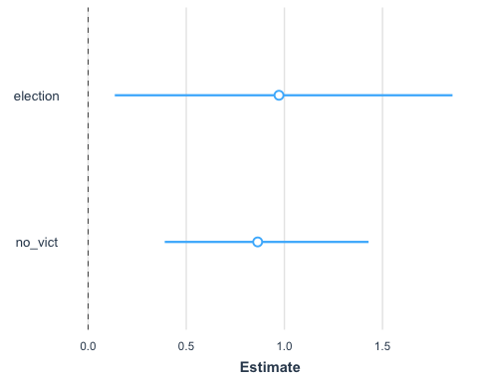
The above results suggest that the number of victims (‘no_vict’) and the election variable (‘election’) significantly influence the likelihood of the affirmed death penalty sentence, both being statistically significant and suggesting that election years significantly influence the likelihood of case affirmation. For each additional victim, the log odds of a case being affirmed increase by 0.86. During election years, the log odds of a case being affirmed increase by about 0.97.

Other Models:

Logistic Regression Models
Figure 4. Regression Coefficients and Standard Errors
 | Model 0 | Model1 | Model1a | Model1b | Model1c | Mode2 | Model3 | Model4 | Model5 | Model6 | Model7
(Intercept) | -2.12 *** | -3.04 *** | -3.24 *** | -2.91 *** | -2.48 *** | -0.93 * | -0.57 | -2.67 *** | 0.13 | 0.13 | -0.36 *
 | (0.57) | (0.85) | (0.90) | (0.76) | (0.72) | (0.45) | (0.30) | (0.69) | (0.09) | (0.12) | (0.15)
election | 0.97 * | 0.95 * | 1.03 * | 1.06 * | 0.94 * | 0.75 | 0.73 | 0.98 * | 0.22 * | 0.22 * | 0.22 *
 | (0.44) | (0.44) | (0.46) | (0.45) | (0.44) | (0.40) | (0.40) | (0.44) | (0.09) | (0.09) | (0.09)
no_vict | 0.86 ** | 1.41 * | 1.41 * | 0.96 *** | 1.34 * |  |  | 0.93 *** | 0.12 *** | 0.10 * | 0.10 *
 | (0.27) | (0.63) | (0.63) | (0.29) | (0.60) |  |  | (0.28) | (0.03) | (0.04) | (0.04)
multipl_off |  | -0.85 | -0.81 |  | -0.87 |  |  |  |  | 0.08 | 0.08
 |  | (0.94) | (0.94) |  | (0.91) |  |  |  |  | (0.11) | (0.11)
felony_m |  | 0.70 | 0.61 | 0.62 |  | 0.45 |  | 0.71 |  | 0.04 | 0.04
 |  | (0.45) | (0.47) | (0.46) |  | (0.42) |  | (0.45) |  | (0.09) | (0.09)
fin_gain |  |  | 0.35 | 0.37 |  | 0.13 |  |  |  | 0.11 | 0.11
 |  |  | (0.46) | (0.45) |  | (0.41) |  |  |  | (0.09) | (0.09)
app_stat |  |  |  |  |  |  |  |  |  | -0.49 ***
 |  |  |  |  |  |  |  |  |  | (0.12)
app_pri |  |  |  |  |  |  |  |  |  |  | 0.49 ***
 |  |  |  |  |  |  |  |  |  |  | (0.12)
N | 110 | 110 | 110 | 110 | 110 | 110 | 110 | 110 | 110 | 109 | 109
AIC | 138.01 | 138.58 | 140.00 | 138.77 | 139.03 | 154.96 | 152.45 | 137.45 | 149.97 | 137.97 | 137.97
BIC | 146.11 | 152.08 | 156.20 | 152.27 | 149.83 | 165.76 | 157.85 | 148.25 | 160.78 | 159.50 | 159.50
Pseudo R2 | 0.22 | 0.26 | 0.26 | 0.25 | 0.23 | 0.06 | 0.04 | 0.25 | 0.19 | 0.37 | 0.37
*** p < 0.001; ** p < 0.01; * p < 0.05.
Figure 5. Coefficients Chart with Coefficients Chart with Confidence Intervals
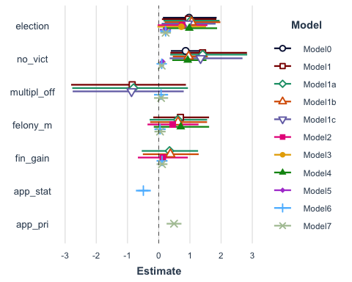
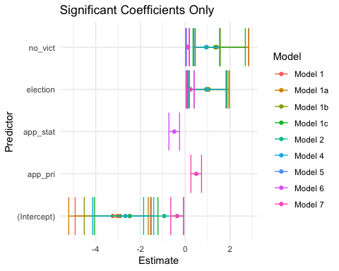

Linear Regression Models for Affirmed Cases (‘affirm’) — unit of analysis Election Year (‘election’)
Figure 6. Regression Coefficients and Standard Errors
 | Model1 | Mode2b | Model3a
(Intercept) | 1.10 | 1.03 | 6.50
 | (1.36) | (0.95) | (4.36)
election1 | 3.41 * | 3.86 ** | 3.53 *
 | (1.15) | (0.69) | (1.21)
no_vict | 0.12 |  | 0.11
 | (0.08) |  | (0.09)
app_stat |  | 0.41
 |  | (0.26)
fin_gain |  | 0.77 *
 |  | (0.23)
multipl_off |  | -0.65 *
 |  | (0.25)
su |  |  | -0.33
 |  |  | (0.43)
smrpc |  |  | -0.58
 |  |  | (0.50)
N | 11 | 11 | 11
R2 | 0.66 | 0.91 | 0.73
*** p < 0.001; ** p < 0.01; * p < 0.05.
Figure 7. Coefficients Chart with Confidence Intervals 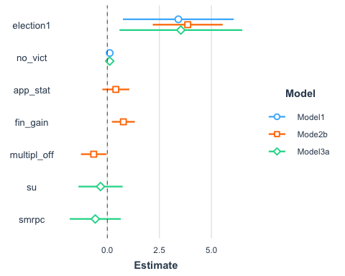
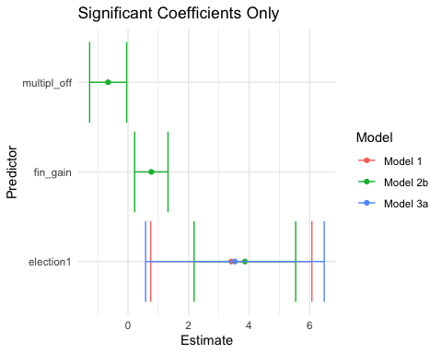

Further Linear Regression Models for Affirmed Cases (‘affirm’) — unit of analysis Election Year (‘election’) with different controls, e.g., number of cases
Figure 7. Regression Coefficients and Standard Errors
 | Model1 | Model2 | Model3 | Model4 | Model5 | Model6 | Model7 | Model8 | Model9 | Model10 | Model11
(Intercept) | 2.83 ** | -0.31 | 0.14 | 1.18 | 0.80 | 8.04 | 1.86 | 5.85 | 1.42 | 9.72 | 2.95
 | (0.79) | (1.34) | (1.15) | (1.01) | (0.93) | (4.43) | (4.33) | (6.28) | (1.85) | (6.80) | (2.26)
election1 | 3.97 ** |  | 2.33 | 2.25 * | 3.07 * | 4.12 *
 | (1.17) |  | (1.07) | (0.85) | (0.90) | (1.18)
case |  | 0.49 ** | 0.34 * | 0.51 ** | 0.28 |  | 0.55 **
 |  | (0.12) | (0.13) | (0.12) | (0.18) |  | (0.14)
multipl_off |  |  |  | -0.64 * | -0.75 * |  |  |  |  | 0.67 | 0.40
 |  |  |  | (0.27) | (0.25) |  |  |  |  | (0.61) | (0.50)
fin_gain |  |  |  |  | 0.53
 |  |  |  |  | (0.32)
smrpc |  |  |  |  |  | -0.72 | 0.04 | -0.34 |  | -0.78
 |  |  |  |  |  | (0.52) | (0.48) | (0.71) |  | (0.81)
su |  |  |  |  |  | -0.13 | -0.56 | -0.49 |  | -0.55
 |  |  |  |  |  | (0.43) | (0.40) | (0.62) |  | (0.75)
no_vict |  |  |  |  |  |  |  | 0.21 | 0.19
 |  |  |  |  |  |  |  | (0.12) | (0.10)
N | 11 | 11 | 11 | 11 | 11 | 11 | 11 | 11 | 11 | 11 | 11
R2 | 0.56 | 0.64 | 0.77 | 0.87 | 0.91 | 0.66 | 0.72 | 0.35 | 0.29 | 0.20 | 0.07
*** p < 0.001; ** p < 0.01; * p < 0.05.
Figure 8. Coefficients Chart with Confidence Intervals
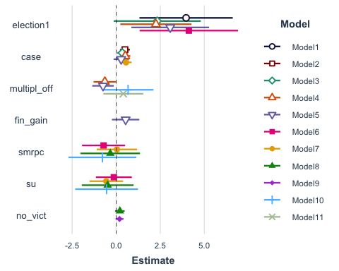
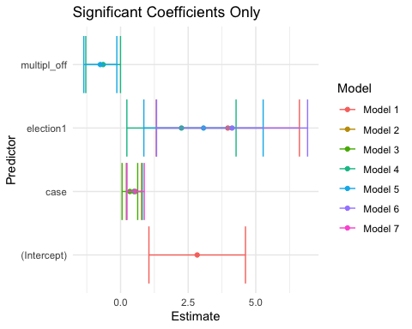
Based on the findings, we were able to reject the null hypothesis and support H1 that the elected judges standing for re-election are less likely to grant post-conviction relief to death row prisoners in election years.

Executives
For this part of the project performed were various inferential analyses—we present the significant outcomes, others are available upon request.
Using our own data, DPIC examined all state clemencies granted in death penalty cases from 1977-2023, for a total of 146 cases, excluding the mass clemency grant in Illinois in 2003. The latter (constituting more than 50% of the overall sample) were excluded from further analysis to prevent skewing our findings as well as to ensure reliability and generalizability. These 146 cases include individual grants and “mass” grants of clemency for more than one person. We coded each case for a number of variables including election cycles, structure of the jurisdiction’s clemency system, and defendant characteristics.
In the logistic regression analysis output below, we tested factors influencing executives’ mass clemency decisions. Sole authority (‘sole_authority’) and the final year of tenure (‘last_year_bin’) are significant predictors; the fact of being up for re-election (‘re_el_num’) was not significant. Sole authority and the last year in office significantly increase the odds of mass clemencies. The model explained a reasonable proportion of the variance based on the pseudo-R2 values.

Logistic Regression
Figure 8. Logistic Regression Results
## Term Estimate Std.Error Odds.Ratio Conf.Low Conf.High
## 1 (Intercept) -2.6222904 0.5419471 0.0726363 0.02510956 0.2101205
## 2 re_el_num 0.5304289 0.4790390 1.6996611 0.66465476 4.3463887
## 3 sole_authority 3.1189326 0.4930318 22.6222204 8.60712376 59.4582893
## 4 last_year_bin 1.2822412 0.6207449 3.6047096 1.06777941 12.1691159
## P.Value
## 1 1.307264e-06
## 2 2.681742e-01
## 3 2.515543e-10
## 4 3.886162e-02
Logistic Regression analysis showcases that the executive’s sole authority (‘sole_authority’) in making a clemency decision and their last year of tenure (‘last_year_bin’) are significant predictors of the outcome variable mass clemency (‘mass_num’).

Chi-Square Tests for Mass Clemencies
##
## 0 1
## 0 58 23
## 1 8 56
##
## Pearson's Chi-squared test with Yates' continuity correction
##
## data: table_data
## X-squared = 48.008, df = 1, p-value = 4.246e-12
## X-squared
## 0.5754015
The Chi-Square Test showcased a significant association between the sole authority and granting clemency. The strong association between sole authority and mass clemencies highlights the individual executive power in clemency practices. The Cramér’s V value of about 0.6 indicates a strong association between these two variables.
Based on the logistic regression findings, we were able to reject the null hypothesis and support H3 that the elected executive officers (governors and presidents) exiting office are more likely to grant clemencies and mass clemencies compared to when they are up for re-election.
Thank You for taking the time to read this document!

References
R Core Team (2023). R: A Language and Environment for Statistical Computing. R Foundation for Statistical Computing, Vienna, Austria. https://www.R-project.org/.

Works Cited:
Chammah, Maurice. Let the lord sort them: The rise and fall of the death penalty. Crown, 2021.
Radelet, Michael L., and Barbara A. Zsembik. “Executive clemency in post-Furman capital cases.” U. Rich. L. Rev. 27 (1992): 289.
Steiker, Carol S., and Jordan M. Steiker. “The Court and Capital Punishment on Different Paths: Abolition in Waiting.” Wash. & Lee J. Civ. Rts. & Soc. Just. 29 (2022): 1.
Stones, Emily. “Exploring the Intersection of Ableism, Image-Building and Hegemonic Masculinity in the Political Communication Classroom.” In Pedagogy, Disability and Communication, 184–202. Routledge, 2017.
Sundby, Scott E. The Death Penalty’s Future: Charting the Crosscurrents of Declining Death Sentences and the McVeigh Factor, 84 Tex. L. Rev. 1929 (2006).
Texas Defender Service. Arbitrary and Capricious: Examining Racial Disparities in Harris County’s Pursuit of Death Sentences, February 22, 2024

Packages:
Arnold J (2023). ggthemes: Extra Themes, Scales and Geoms for ‘ggplot2’. R package version 5.0.0, https://CRAN.R-project.org/package=ggthemes.
Fox J, Weisberg S (2019). An R Companion to Applied Regression, Third edition. Sage, Thousand Oaks CA. https://socialsciences.mcmaster.ca/jfox/Books/Companion/.
Gohel D, Skintzos P (2024). flextable: Functions for Tabular Reporting. R package version 0.9.6, https://CRAN.R-project.org/package=flextable.
Hlavac, M (2022). stargazer: Well-Formatted Regression and Summary Statistics Tables. R package version 5.2.3. https://CRAN.R-project.org/package=stargazer.
Hothorn T, Bretz F, Westfall P (2008). “Simultaneous Inference in General Parametric Models.” Biometrical Journal, 50(3), 346-363.
Kassambara A (2023). ggpubr: ‘ggplot2’ Based Publication Ready Plots. R package version 0.6.0, https://CRAN.R-project.org/package=ggpubr.
———– (2023). ggcorrplot: Visualization of a Correlation Matrix using ‘ggplot2’. R package version 0.1.4.1, https://CRAN.R-project.org/package=ggcorrplot.
Leifeld, Philip (2013). texreg: Conversion of Statistical Model Output in R to LaTeX and HTML Tables. Journal of Statistical Software, 55(8), 1-24. URL https://doi.org/10.18637/jss.v055.i08.
Long JA (2022). jtools: Analysis and Presentation of Social Scientific Data. R package version 2.2.0, https://cran.r-project.org/package=jtools.
Ooms J (2024). writexl: Export Data Frames to Excel ‘xlsx’ Format. R package version 1.5.0, https://CRAN.R-project.org/package=writexl.
Revelle W (2024). psych: Procedures for Psychological, Psychometric, and Personality Research. Northwestern University, Evanston, Illinois. R package version 2.4.3, https://CRAN.R-project.org/package=psych.
Rizopoulos D (2006). ltm: An R package for Latent Variable Modelling and Item Response Theory Analyses, Journal of Statistical Software, 17 (5), 1-25. https://doi.org/10.18637/jss.v017.i05
Robinson D, Hayes A, Couch S (2023). broom: Convert Statistical Objects into Tidy Tibbles. R package version 1.0.5, https://CRAN.R-project.org/package=broom.
Wickham H (2007). Reshaping Data with the reshape Package. Journal of Statistical Software, 21(12), 1-20. http://www.jstatsoft.org/v21/i12/.
———– (2016) ggplot2: Elegant Graphics for Data Analysis. Springer-Verlag New York.
Wickham H, Averick M, Bryan J, Chang W, McGowan LD, François R, Grolemund G, Hayes A, Henry L, Hester J, Kuhn M, Pedersen TL, Miller E, Bache SM, Müller K, Ooms J, Robinson D, Seidel DP, Spinu V, Takahashi K, Vaughan D, Wilke C, Woo K, Yutani H (2019). “Welcome to the tidyverse.” Journal of Open Source Software, 4(43), 1686. doi:10.21105/joss.01686 https://doi.org/10.21105/joss.01686.
Wickham H, François R, Henry L, Müller K, Vaughan D (2023). dplyr: A Grammar of Data Manipulation. R package version 1.1.4, https://CRAN.R-project.org/package=dplyr.
Wickham H, Pedersen T, Seidel D (2023). scales: Scale Functions for Visualization. R package version 1.3.0, https://CRAN.R-project.org/package=scales.
Wickham H, Vaughan D, Girlich M (2024). tidyr: Tidy Messy Data. R package version 1.3.1, https://CRAN.R-project.org/package=tidyr.
Xie Y (2023). knitr: A General-Purpose Package for Dynamic Report Generation in R. R package version 1.45, https://yihui.org/knitr/.
———– (2023). tinytex: Helper Functions to Install and Maintain TeX Live, and Compile LaTeX Documents. R package version 0.49, https://github.com/rstudio/tinytex.

Versions

Original Release Date:
2024-07-02

